What is the Cloud? What are the different types of Cloud?

**What is the Cloud exactly?**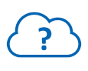

The Cloud (Computing) is a way of providing access to computer resources, characterized by its **self-service** availability, **elasticity**, **openness**, **mutualization** and **pay-per-use:**

**Self-service and on-demand resources** of storage capacity and computing power, according to the customer’s needs. This contrasts with so-called “traditional” computing where any need to change an application requires manual operations and therefore time. In the Cloud, the need, automatically detected by the application or at the customer’s request, is taken into account and satisfied immediately.

**Openness:**Cloud services are **accessible through a network**, using **standardized** techniques, whether from a computer, a smartphone or a tablet.

**Mutualization:**the Cloud **mutualizes** its IT resources (servers, CPU, RAM, storage, network) to serve its customers, to whom the ordered resources are allocated according to automatic processes. Mutualization improves **scalability** and **elasticity**; it facilitates **the automatic adaptation of resources** to **variations in demand**.

**Pay-per-use:**the quantity of services consumed in the Cloud is measured for purposes of control, adaptation of technical means and billing.

With the Cloud, we talk about "XaaS". What's XaaS?

The acronym XaaS refers to Everything-as-a-Service. This term refers to the different models of Cloud computing “as a service”.

Indeed, with the Cloud, we no longer speak of infrastructure components but of services, which explains the syntax of the terms (*aaS).  XaaS services are organized in 3 categories.



* **IaaS** (**I**nfrastructure **a**s **a** **S**ervice): provides CPU, Storage, RAM, Network.



* **PaaS** (**P**latform **a**s **a** **S**ervice): provides ready-to-use middlewares (database, web server, etc.).



* **SaaS** (**S**oftware **a**s **a** **S**ervice): provides ready-to-use softwares (CRM, expense claim management, online office automation tools such as Office 365, payroll management, etc.).

We talk about “**Infrastructure as a Service**” in the case where:

* The client manages the middlewares and softwares (executables, settings, databases).
* The Cloud provider manages server hardware, virtualization layers, storage, networks.

It is a model where the customer has, on a **paying subscription basis**, an **IT infrastructure**(servers, storage, backup, network) that is physically located at the Cloud provider.

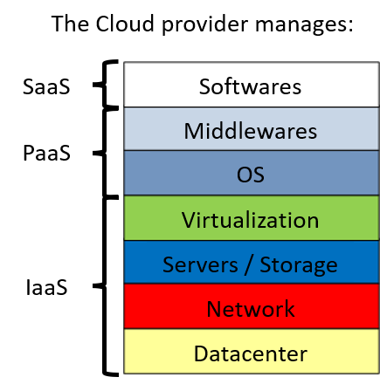

XAAS SERVICES IN DETAIL

**Infrastructure as a Service (IaaS)**

It’s the lowest level of service. It consists of providing access to a virtualized computer park. Virtual machines on which the customer can install an operating system and applications. This service is similar to traditional data center hosting services, and the trend is towards higher level services (PaaS or SaaS) that are more abstract in terms of technical details.

**Platform as a Service (PaaS)**

In this type of service, the operating system and infrastructure tools are the responsibility of the Cloud provider. The customer has direct access to specialized services (web front-ends, middlewares, databases, etc.) that can be customized: the customer chooses, in a Marketplace, the design of the technical solution to be deployed. The Cloud provider will execute the implementation with its own scripts.

**Advantage**

* The customer of the Cloud solution will be able to focus on the business application to be implemented.

**Disadvantage**

* In the event that the PaaS provider decides to no longer authorize the use of a tool or a version of the tool, or to interrupt or develop its offer, the consumer must adapt within the timeframe chosen by the PaaS provider.

**Software as a Service (SaaS)**

In this type of service, softwares are made available to clients, accessible from a Web browser or installed on a PC for rental. The customer does not have to worry about making updates, adding security patches and ensuring the availability of the service.

**Advantages**

* Rapid implementation and provision of services for the customer. No need to worry about software packages and licenses anymore. The service is immediately « available online »
* As the software is managed by the provider, customers no longer need to worry about deployments, maintenance and technical evolution phases of the service.

**Disadvantages**

* It is difficult to manage service interruptions: customers have to organize themselves around the constraints imposed by the SaaS provider;
* It is necessary to comply with the supplier’s prerequisites for a good use;
* The customer is subject to the SaaS product lifecycle by the Cloud provider, particularly in the event of a lack or abandonment of functionality.

A SaaS provider can operate PaaS-type services, which in turn can use IaaS.

The use of services (IaaS-PaaS-SaaS), by its nature, is therefore a shared responsibility.

Below is a simplified representation of responsibilities (in the box = responsibility entrusted to the Cloud provider).

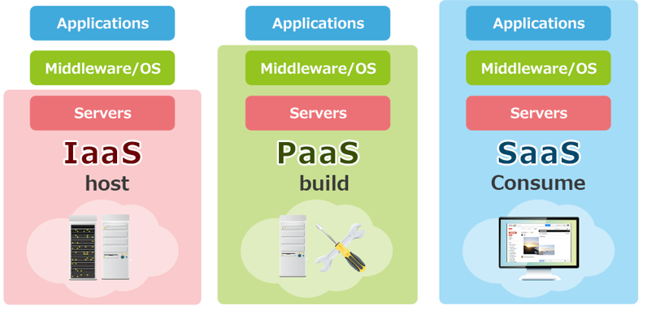

THE DIFFERENT TYPES OF CLOUD

**The Public Cloud **

**The infrastructure is mutualized**and**is shared between several companies and individuals.**It is owned by a service provider.**The Service Level Agreement (SLA) is the same for all users and is defined by the provider.**

* Natively, Public Cloud services are provided in a virtualized environment, built using physical resources in pools shared with all other subscribers.

The services are accessible via the Internet.

The Public Cloud offers the following features and benefits:

* High resource scalability so that an application can respond flexibly to charge fluctuations.
* Only leased resources are billed.
* The pricing model is based on what is consumed (no cost on unused resources).

=> No more need to tie up resources to anticipate future needs.

* The (very) high availability of access to environments.

The multitude of physical components implemented by the supplier to create a Public Cloud means that there is no (theoretically) infrastructure SPOF (Single Point Of Failure: a system-part whose failure stops the system from working).

* The services offered can meet most of the requirements and use cases sought by a company.
* Customers have access to a standardized environment.

**The Private Cloud 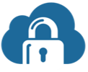**

It is an environment exclusively used by a company.

The company is then responsible for the purchase, installation and management of servers, networks, storage, etc., all of which are protected by security solutions implemented by the company.

The Private Cloud can be hosted in a company-owned datacenter or hosted by a partner.

**The Hybrid Cloud 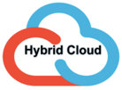**

It is a use of several Clouds where all combinations between Private and Public Clouds are possible.

These combinations of several types of accommodation totally independent of each other require to respect :

* Technological standards to be able to communicate between Clouds.
* A network connectivity that can meet the needs.

The Hybrid Cloud makes it possible to shift workloads between different types of hosting according to changing needs, cost reduction or in case of a need for dynamic increase of mass resources.

THE CLOUD MARKET

According to the RightScale (2019) report on the state of cloud computing, 91% of companies reported using a Public Cloud service.

Gartner’s most recent data on the global market for infrastructure as a Cloud IaaS service indicates annual revenues of $32.4 billion. This is a 31.3% growth from $24.7 billion in 2017.

According to Gartner, the market is dominated by five vendors that account for nearly 80% of the global Cloud IaaS market share in 2018.

